

Semester One Examination, 2016

Question/Answer Booklet

MATHEMATICS

SOLUTIONS
SPECIALIST
UNIT 1

Section Two:

Calculator-assumed

Student Number: In figures

In words

Your name

Time allowed for this section
Reading time before commencing work: ten minutes
Working time for section: one hundred minutes

Materials required/recommended for this section
To be provided by the supervisor
This Question/Answer Booklet
Formula Sheet (retained from Section One)

To be provided by the candidate
Standard items: pens (blue/black preferred), pencils (including coloured), sharpener, correction fluid/tape, eraser, ruler, highlighters

Special items: drawing instruments, templates, notes on two unfolded sheets of A4 paper, and up to three calculators approved for use in the WACE examinations

Important note to candidates
No other items may be taken into the examination room. It is your responsibility to ensure that you do not have any unauthorised notes or other items of a non-personal nature in the examination room. If you have any unauthorised material with you, hand it to the supervisor before reading any further.

Structure of this paper

Section | Number of questions available | Number of questions to be answered | Working  time (minutes) | Marks available | Percentage of exam
Section One:  Calculator-free | 7 | 7 | 50 | 49 | 35
Section Two:  Calculator-assumed | 13 | 13 | 100 | 102 | 65
 |  |  | Total | 151 | 100

Instructions to candidates

- The rules for the conduct of examinations are detailed in the school handbook. Sitting this examination implies that you agree to abide by these rules.

- Write your answers in this Question/Answer Booklet.

- You must be careful to confine your response to the specific question asked and to follow any instructions that are specified to a particular question.

- Spare pages are included at the end of this booklet. They can be used for planning your responses and/or as additional space if required to continue an answer.
- Planning: If you use the spare pages for planning, indicate this clearly at the top of the page.
- Continuing an answer: If you need to use the space to continue an answer, indicate in the original answer space where the answer is continued, i.e. give the page number. Fill in the number of the question that you are continuing to answer at the top of the page.

- Show all your working clearly. Your working should be in sufficient detail to allow your answers to be checked readily and for marks to be awarded for reasoning. Incorrect answers given without supporting reasoning cannot be allocated any marks. For any question or part question worth more than two marks, valid working or justification is required to receive full marks. If you repeat any question, ensure that you cancel the answer you do not wish to have marked.

- It is recommended that you do not use pencil, except in diagrams.

- The Formula Sheet is not to be handed in with your Question/Answer Booklet.

Section Two: Calculator-assumed 65% (102 Marks)
This section has thirteen (13) questions. Answer all questions. Write your answers in the spaces provided.

Working time for this section is 100 minutes.

Question 8 (5 marks)
In the diagram below, AB is a tangent to the circle and .

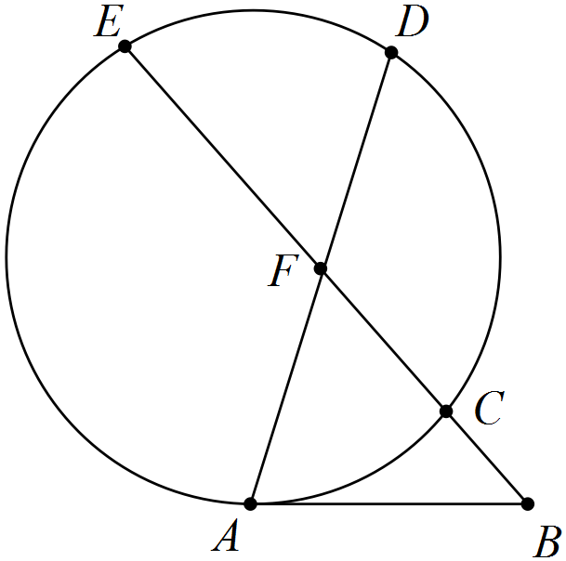

If and , determine the lengths of

(a) AB. (2 marks)
Solution
Specific behaviours
uses secant-tangent relationship
calculates length

(b) CF. (1 mark)
Solution
Specific behaviours
calculates length

(c) AF. (2 marks)
Solution
Specific behaviours
uses product of chord intervals
calculates length

Question 9 (7 marks)
Two forces act on body. The first has magnitude 250 N and acts in direction 240° and the second has magnitude 410 N and acts in direction 170°.

(a) Determine the resultant of the two forces. (4 marks)
Solution
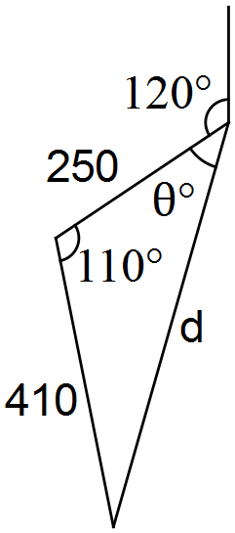

Resultant has magnitude 548.4 N in direction 195.4°.
Specific behaviours
diagram
uses cosine rule to determine magnitude
uses sine rule to determine angle
states resultant as magnitude and direction

(b) The work done, in joules, by a force in moving a body is the scalar product of the force, in newtons, and the displacement, in metres. Determine the total work done by the two forces, to the nearest 100 joules, if the body moves 45 metres in direction 215°. (3 marks)

Solution
Specific behaviours
determines angle between directions
uses scalar product
rounds correctly

Question 10 (8 marks)
(a) Use a counterexample to demonstrate that each of following statements are false.

(i) . (2 marks)
Solution
If , then but and so statement is false.
Specific behaviours
supplies values for counterexample
uses values to show statement is false

(ii) If, then is always prime. (2 marks)
Solution
Since is clearly not prime, then the statement is false
Specific behaviours
supplies value of n so that is not prime
shows why supplied value is not prime

(b) The statement 'if a natural number is a multiple of 4 and 5 then the natural number is a multiple of 20' is true.

(i) Write the contrapositive of the statement and explain whether or not the contrapositive is also true. (2 marks)
Solution
If a natural number is not a multiple of 20 then it is not a multiple of 4 and 5.
This is true, as contrapositive always true if original statement true.
Specific behaviours
writes contrapositive
states with reason that it is true

(ii) Write the converse of the statement and explain whether or not the converse is also true. (2 marks)
Solution
If a natural number is a multiple of 20 then it is a multiple of 4 and 5.
This is true, as if a number has a factor of 20 then it will also have factors of 4 and 5.
Specific behaviours
writes converse
explains converse is true

Question 11 (8 marks)
Fifteen children at a summer camp are to be divided into two groups of nine and six.

(a) Determine the number of different groupings. (2 marks)
Solution
groupings
Specific behaviours
uses combinations
calculates correct number

(b) Determine how many groupings are possible if the two youngest children must be in the same group. (3 marks)
Solution
Specific behaviours
calculates ways using larger group
calculates ways using smaller group
calculates total number of groupings

(c) If ten of the fifteen were girls, in how many of the different groupings do both groups contain more girls than boys? (3 marks)
Solution
Large group must have 6G3B or 5G4B (so that other has 4G2B or 5G1B).
Specific behaviours
determines required groupings
calculates first grouping
calculates second grouping and total

Question 12 (7 marks)
Vector a has magnitude 6 units and acts on a bearing of 310°. Vector b has magnitude 12 units and acts on a bearing of 070°.

(a) Determine the magnitude and direction of . (4 marks)
Solution
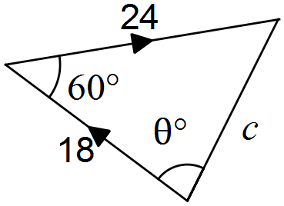
Specific behaviours
sketches diagram to show addition of multiples of vectors
uses cosine rule to determine magnitude
uses sine rule to determine angle
states direction as bearing

(b) Determine the value of the constant k if the direction of is due north. (3 marks)
Solution
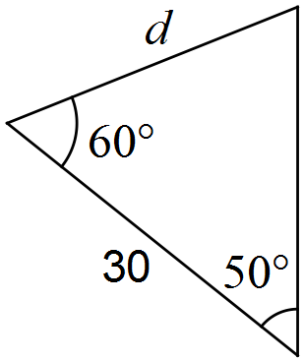
Specific behaviours
sketches diagram
determines required magnitude
determines k

Question 13 (9 marks)
(a) AB is a diameter of a circle centre O. C is a point on the circumference. D is a point on AC such that OD bisects . Prove that OD is parallel to BC. (4 marks)
Solution
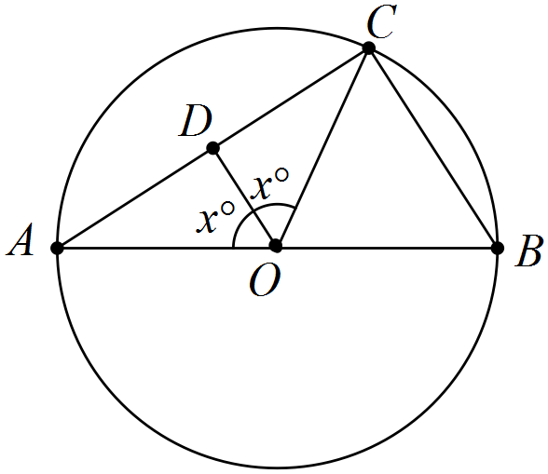
Specific behaviours
shows information using diagram
determines angle ABC
determines angle BCO
uses alternate angles to explain parallel

(b) In the diagram below, FCG is a tangent to the circle ABC. BD bisects , CD bisects , BE bisects and CE bisects . If and , determine the ratio, in simplest form, of . (5 marks)

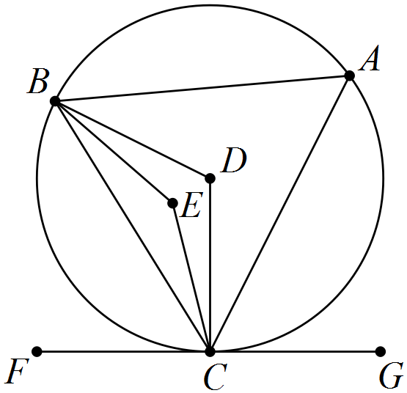
Solution
ABC is isosceles and angle bisectors will intersect on line of symmetry and .
Specific behaviours
explains ABC isosceles and results
uses angle in opposite segment
determines DBC and EBC
determines BAC, BDC and BEC
determines simplified ratio

Question 14 (9 marks)
Points O, P, Q and R have position vectors , , and .

(a) Determine the value of y if . (2 marks)
Solution
Specific behaviours
writes magnitude equation
states both +ve and -ve solutions

(b) Determine the value of x if $\vec{OQ}$ $\vec{QR}$. (3 marks)
Solution
Specific behaviours
determines $\vec{QR}$
solves scalar product equal to zero
states both values of x

(c) Determine the values of x and y if R lies on the line between P and Q such that . (4 marks)
Solution
Specific behaviours
writes vector equation
substitutes position vectors
solves for x using i-coefficients
solves for y using j-coefficients

Question 15 (9 marks)
(a) ABCDEF is a regular hexagon in which $\vec{BC}$ represents b and $\vec{FC}$ represents 2a.

Express the vectors $\vec{CD}$, $\vec{EA}$ and $\vec{BE}$ in terms of a and b. (3 marks)
Solution
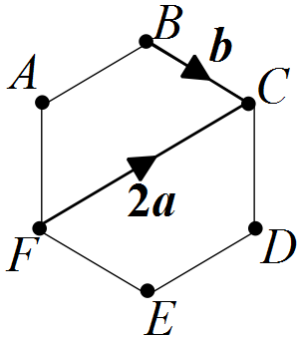

$\vec{CD}$ , $\vec{EA}$ and $\vec{BE}$.
Specific behaviours
determines $\vec{CD}$
determines $\vec{EA}$
determines $\vec{BE}$

(b) Given c and d are vectors such that , and the angle between their directions is 40°, determine

(i) . (3 marks)
Solution
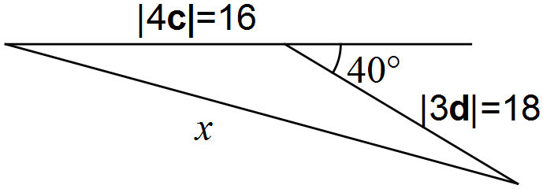
Specific behaviours
diagram to show vectors
uses cosine rule
determines magnitude

(ii) the angle between d and . (3 marks)
Solution
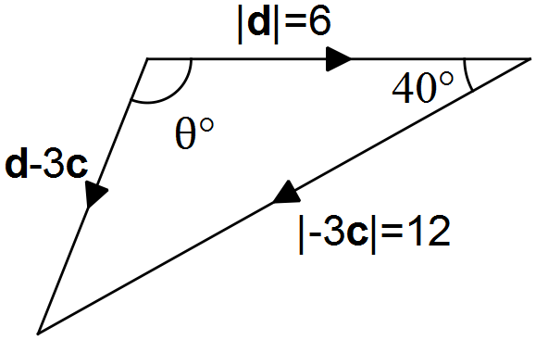
Specific behaviours
diagram to show vectors
determines magnitude
determines angle

Question 16 (10 marks)
(a) If a room contains 75 adults, use the pigeonhole principle to explain why a group containing at least 11 of these people could be chosen so that all were born on the same day of the week. (3 marks)
Solution
There are 7 days of week (pigeonholes) in which to place 75 people (pigeons). If n pigeons are assigned to m pigeonholes, then one of the pigeonholes must contain at least pigeons.
. So at least 11 share same day of week.
Specific behaviours
describes weekdays as pigeonholes
describes adults as pigeons
explains why at least 11 pigeons in one pigeonhole.

(b) Twelve senior students each brought at least one toy to school to donate to the pre-primary centre. Given that a total of 75 toys were donated, prove that at least two of the senior students brought in the same number of toys.
Hint: Think of a contradiction. (3 marks)
Solution
Contradiction: Assume they all brought a different number of toys.
Smallest possible number of toys donated would then be toys.
78 is more than 75, which contradicts assumption and so at least two must have brought the same number of toys.
Specific behaviours
states assumption that contradicts
calculates smallest number of toys
shows contradiction

(c) Determine how many numbers between 1 and 150 inclusive are multiples of 3, 4 or 5.
(4 marks)
Solution
Multiples of 3: 50
Multiples of 4: 37
Multiples of 5: 30

Multiples of 3 & 4: 12
Multiples of 3 & 5: 10
Multiples of 4 & 5: 7

Multiples of 3 & 4 & 5: 2

Specific behaviours
calculates individual multiples
calculates paired multiples
calculates triple multiples
calculates total

Question 17 (8 marks)
A boat with a constant speed of 6 ms⁻¹ is required to leave its mooring and motor directly to a jetty located 1 045 metres away on a bearing of 155°. A current of 1.5 ms⁻¹ is running on a bearing of 200°.

(a) Sketch a diagram to that can be used to determine the direction the boat should steer.
(2 marks)
Solution
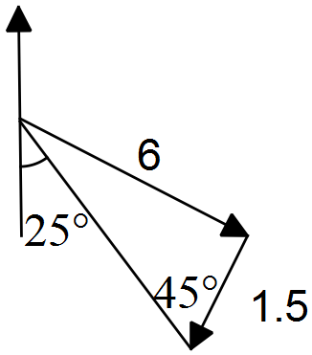
Specific behaviours
shows directions
shows magnitudes

(b) Determine the bearing that the boat should steer. (3 marks)
Solution
Specific behaviours
uses sine rue
determines angle
determines bearing

(c) Determine the time taken for the boat to reach the jetty. (3 marks)
Solution
Specific behaviours
uses cosine rule
determines speed over ground
determines time

Question 18 (7 marks)
(a) Let , and .

Prove that the scalar product is distributive over vector addition: .
(4 marks)
Solution
Specific behaviours
sums components of b and c
uses scalar product
expands result
re-writes as scalar product using components

(b) Given and ,
determine . (3 marks)
Solution
Specific behaviours
factorises expression
substitutes and simplifies
calculates scalar product

Question 19 (8 marks)
(a) Determine the number of ways that ten different coloured cubes can be placed in a line.
(1 mark)
Solution
Specific behaviours
determines number of ways

(b) Determine the number of ways that six different coloured cubes can be placed in a line if the blue, red and green cubes must be together. (2 marks)
Solution
Specific behaviours
groups blue, red and green as one item and arranges within
arranges all four items

(c) Eight identical cubes, coloured red, red, red, blue, blue, green, orange and yellow, are arranged in a line.

(i) Determine the number of arrangements in which the red cubes are all adjacent.
(2 marks)
Solution
Treat 3 reds as one item, leaving 6 items, 2 alike:
Specific behaviours
treats reds as one item
arranges remaining items correctly

(ii) Determine the number of arrangements in which no two red cubes are adjacent.
(3 marks)
Solution
Remove all reds and arrange remaining cubes, 2 alike:
With five cubes, there are six spaces to insert a red cube, so choose any three of these six: .
Since choices for position and arrangements of cubes independent, then total number of ways is:
Specific behaviours
arranges remaining 5 cubes
calculates number of spaces
calculates total ways

Question 20 (7 marks)
The diagram shows three semicircles with diameters AD, AB and BD, where B is a point on the diameter AD. Point C is the centre of the semicircle with diameter BD. Line BE is perpendicular to diameter AD and meets the largest semicircle at E. Points F and H are the intersections of lines AE and DE with the smaller semicircles. Point G is the intersection of lines FH and BE.

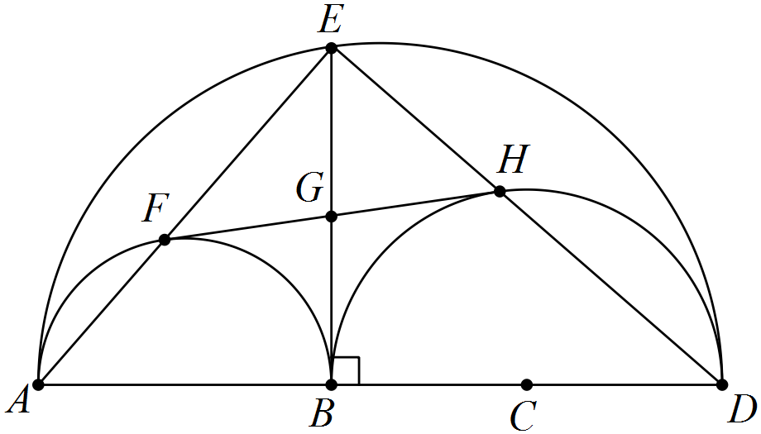

(a) Explain why BFEH is a rectangle. (2 marks)
Solution
Specific behaviours
uses angle in semicircle
explains three angles are right, and so is a rectangle

(b) Prove that and are congruent. (3 marks)
Solution
Specific behaviours
uses radii
uses diagonals bisecting
uses common side

(c) Deduce that line FH is a tangent to the semicircle with diameter BD. (2 marks)
Solution
Specific behaviours
uses corresponding angles
deduces must be tangent

Additional working space

Question number: _________

Additional working space

Question number: _________

© 2016 WA Exam Papers. Narrogin Senior High School has a non-exclusive licence to copy and communicate this paper for non-commercial, educational use within the school. No other copying, communication or use is permitted without the express written permission of WA Exam Papers.

